**INSTRUCTIONS FOR MEMORY TEST**

Now you will do a memory test. You will see a series of items, one at a time, on the computer screen. You will have seen some of these pictures earlier on in the experiment (i.e. in one of the earlier stages). 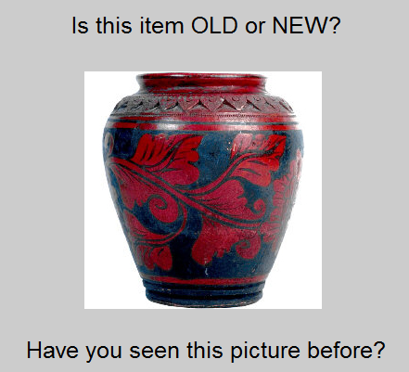

**#1: Is the item OLD or NEW?**

Firstly, the computer will ask you if you have seen this picture before. Press the LEFT arrow key if you think it is OLD (i.e. that you think you have seen this picture before), or the RIGHT arrow key if you think it is NEW.

**#2: Are you SURE or did you GUESS?**

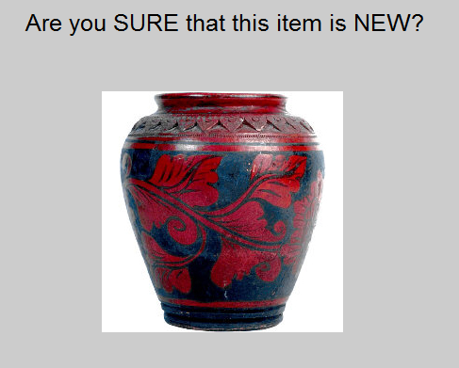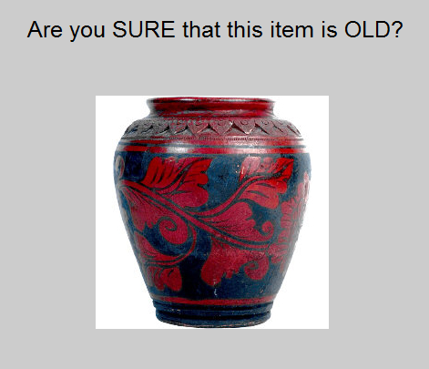Then, you will have to say how SURE you are about your Old/New decision. Press the LEFT arrow key if you are SURE, or the RIGHT arrow key if it is a GUESS.

**#3: Do you REMEMBER seeing the item, or do you just KNOW that it is old?**

If you thought the item was OLD, you will also be asked two follow up questions. Firstly, you will be asked if your memory for the item is a REMEMBER-type memory, or KNOW-type memory.

A REMEMBER-type memory is a memory where you can recall some detail from when you first saw the item. For example, if you can remember having a certain thought when you saw the picture the first time, this would be a REMEMBER-type memory.

A KNOW-type memory is a memory where you CANNOT remember any such detail about this item. If it just looks familiar to you, but you cannot remember anything beyond that, then you should give a KNOW response.

It is very important that you understand this distinction, and think carefully about what type of memory you are experiencing for each item that you recognize as being old. Please ask the experimenter if you are still unsure about how to make this decision!

**#4: Where on the screen did you see this item before?**

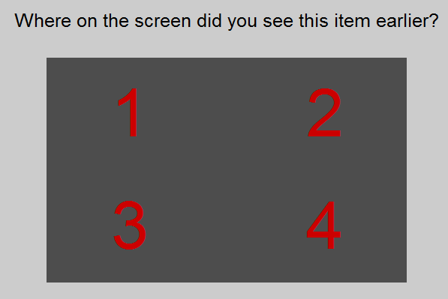Lastly, the computer will then ask you about WHERE on the screen the item was displayed, when you first saw it. The first time you saw the item (in an earlier stage of the experiment), it would have been presented in one of the four quadrants of the screen. Can you remember where on the screen this item was displayed when you first saw it? If you are completely stumped about this question, just make your best guess.

You will use the left and right arrow keys (with your right hand) and the 1-4 number keys on the left side of the keyboard (with your left hand). Look carefully at the instructions on the computer screen if you forget which button means what when you are doing the task (or ask the experimenter directly if you get confused!).

**Please call the experimenter now!**